1. What is SQL?
It stands for Structured Query Language, and it's a programming language used for interaction with relational database management systems (RDBMS). This includes fetching, updating, inserting, and removing data from tables.
2. Give some examples of common SQL commands of each type.
- DDL(Definition): CREATE, ALTER, DROP, TRUNCATE, and ADD COLUMN
- DML(Manipulation): UPDATE, DELETE, and INSERT
- DCL(Control): GRANT and REVOKE
- TCL(Transmission control): COMMIT, SET TRANSACTION, ROLLBACK, and SAVEPOINT
- DQL(Query): – SELECT
3. What is DBMS, and what types of DBMS do you know?
It stands for Database Management System, a software package used to perform various operations on the data stored in a database, such as accessing, updating, wrangling, inserting, and removing data. There are various types of DBMS, such as relational, hierarchical, network, graph, or object-oriented. These types are based on the way the data is organized, structured, and stored in the system.
4. What is RDBMS? Give some examples of RDBMS.
It stands for Relational Database Management System. It's the most common type of DBMS used for working with data stored in multiple tables related to each other by means of shared keys. The SQL programming language is designed to interact with RDBMS. Some examples of RDBMS are MySQL, PostgreSQL, Oracle, MariaDB, etc.
5. What is a constraint, and why use constraints?
A set of conditions defining the type of data that can be input into each column of a table. Constraints ensure data integrity in a table and block undesired actions.
6. What SQL constraints do you know?
- DEFAULT – provides a default value for a column.
- UNIQUE – allows only unique values.
- NOT NULL – allows only non-null values.
- PRIMARY KEY – allows only unique and strictly non-null values (NOT NULL and UNIQUE).
- FOREIGN KEY – provides shared keys between two or more tables.
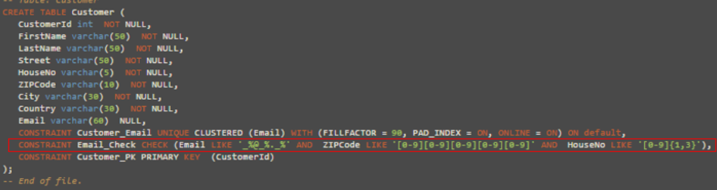
7. What types of joins do you know?
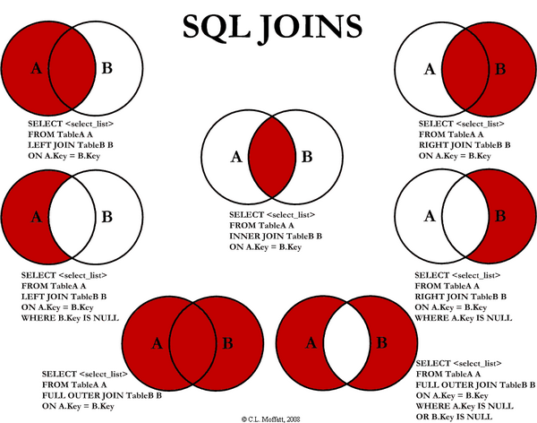8. What is a primary key?
A column (or multiple columns) of a table to which the PRIMARY KEY constraint was imposed to ensure unique and non-null values in that column. In other words, a primary key is a combination of the NOT NULL and UNIQUE constraints. The primary key uniquely identifies each record of the table. Each table should contain a primary key and can't contain more than one primary key.
9. What is a unique key?
A column (or multiple columns) of a table to which the UNIQUE constraint was imposed to ensure unique values in that column, including a possible NULL value (the only one).
10. What is a foreign key?
A column (or multiple columns) of a table to which the FOREIGN KEY constraint was imposed to link this column to the primary key in another table (or several tables). The purpose of foreign keys is to keep connected various tables of a database.
11. Types of index?
Feature | Clustered Index | Non-Clustered Index
Speed | Faster for range-based queries and sorting. | Slower for range-based queries but faster for specific lookups.
Memory Usage | Requires less memory for operations. | Requires more memory due to additional index structure.
Data Storage | The clustered index stores data in the table itself. | The non-clustered index stores data separately from the table.
Number of Indexes per Table | A table can have only one clustered index. | A table can have multiple non-clustered indexes.
Disk Storage | The clustered index can store data on the disk. | The non-clustered index stores the index structure (B-tree) on disk with pointers to the data pages.
Pointer Storage | Stores pointers to the data blocks, not the data itself. | Stores both the indexed value and a pointer to the actual row in a separate data page.
Leaf Nodes | Leaf nodes contain the actual data itself. | Leaf nodes contain indexed columns and pointers to data.
Data Order | Defines the physical order of the rows in the table. | Defines the logical order of data in the index, not the table.
Index Structure | The data is physically reordered to match the index. | The logical order does not match the physical order of rows.
Primary Key | Primary keys are by default clustered indexes. | Composite keys used with unique constraints are non-clustered.
Size | Typically larger, especially for large primary clustered indexes. | Smaller than clustered indexes, especially when composite.
Use Case | Ideal for range queries and sorting. | Suitable for optimizing lookups and queries on non-primary columns.
Impact on Table | A clustered index directly impacts the table's physical storage order. | A non-clustered index does not affect the physical storage order of the table.

12. What types of indexes do you know?
- Unique index – doesn't allow duplicates in a table column and hence helps maintain data integrity.
- Clustered index – defines the physical order of records of a database table and performs data searching based on the key values. A table can have only one clustered index.
- Non-clustered index – keeps the order of the table records that don't match the physical order of the actual data on the disk. It means that the data is stored in one place and a non-clustered index – in another one. A table can have multiple non-clustered indexes.
Clustered Index:
CREATE CLUSTERED INDEX Clustered_Index_Name ON TableName (ColName);
GO

Non clustered Index:
CREATE NONCLUSTERED INDEX NonClustered_Index_Name ON TableName(Col1,Col2,Col3)

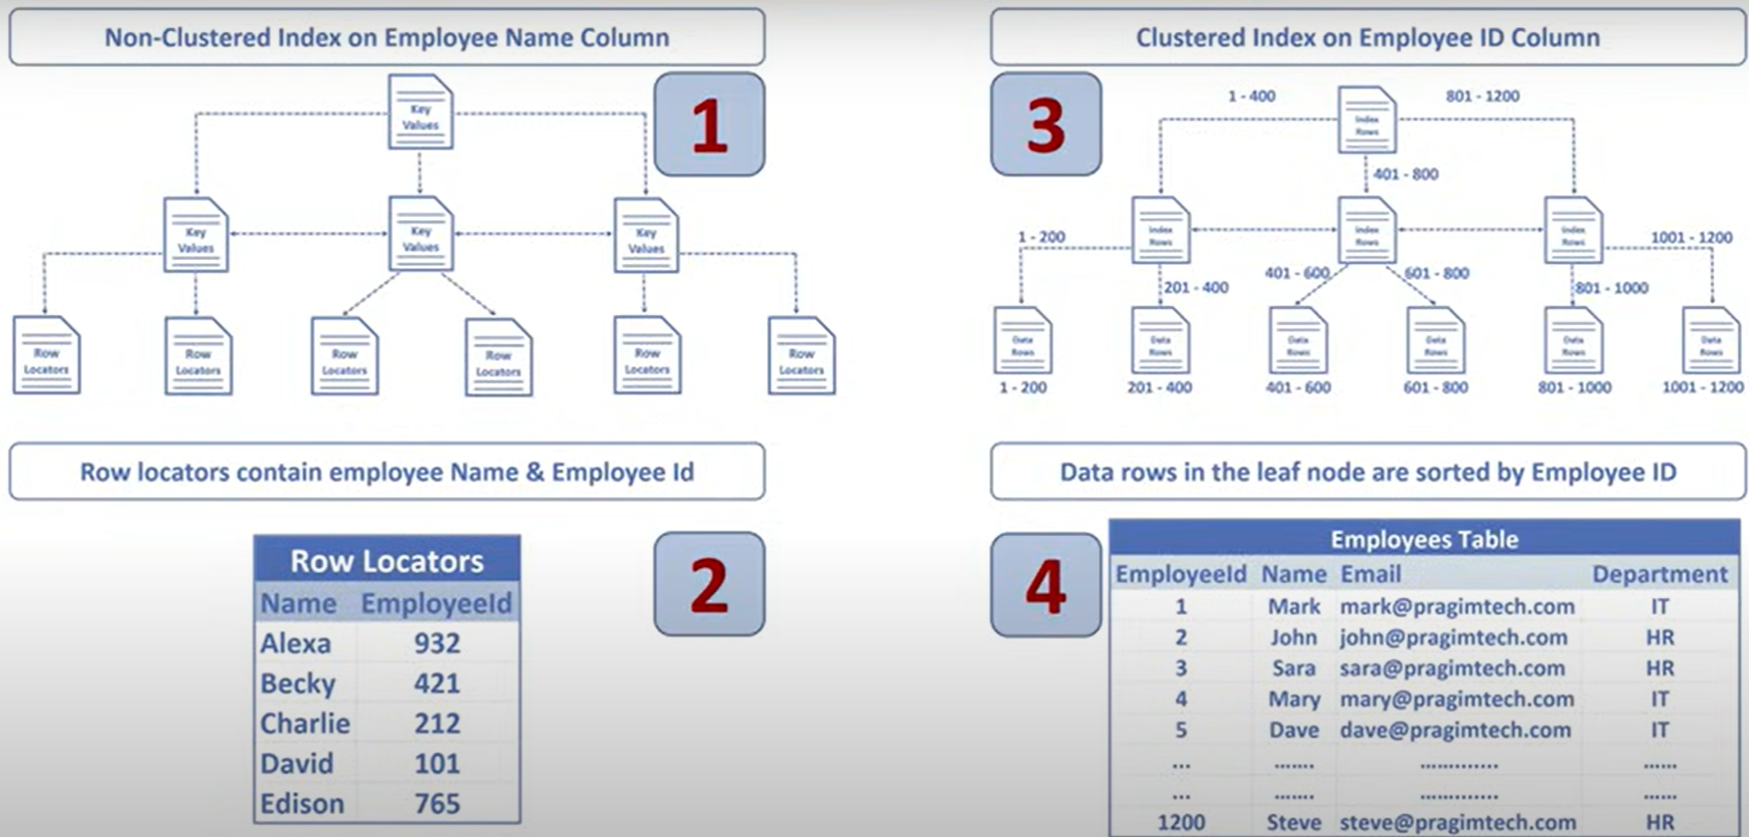

13. What types of SQL operators do you know?
- Arithmetic (+, -, *, /, etc.)
- Comparison (>, <, =, >=, etc.)
- Compound (+=, -=, *=, /=, etc.)
- Logical (AND, OR, NOT, BETWEEN, etc.)
- String (%, _, +, ^, etc.)
- Set (UNION, UNION ALL, INTERSECT, and MINUS (or EXCEPT))
14. What is the difference between SQL and NoSQL?
SQL databases are relational, structured, and use tables with predefined schemas, while NoSQL databases are non-relational, schema-less, and designed to handle unstructured or semi-structured data.
15. What aggregate functions do you know?
- AVG() – returns the average value
- SUM() – returns the sum of values
- MIN() – returns the minimum value
- MAX() – returns the maximum value
- COUNT() – returns the number of rows, including those with null values
- FIRST() – returns the first value from a column
- LAST()– returns the last value from a column
16. What scalar functions do you know?
- LEN() (in other SQL flavors – LENGTH()) – returns the length of a string, including the blank spaces
- UCASE() (in other SQL flavors – UPPER()) – returns a string converted to the upper case
- LCASE() (in other SQL flavors – LOWER()) – returns a string converted to the lower case
- INITCAP() – returns a string converted to the title case (i.e., each word of the string starts from a capital letter)
- MID() (in other SQL flavors – SUBSTR()) – extracts a substring from a string
- ROUND() – returns the numerical value rounded to a specified number of decimals
- NOW() – returns the current date and time
17. What are case manipulation functions? Give some examples.
Case manipulation functions represent a subset of character functions, and they're used to change the case of the text data. With these functions, we can convert the data into the upper, lower, or title case.
- UCASE() (in other SQL flavors – UPPER()) – returns a string converted to the upper case
- LCASE() (in other SQL flavors – LOWER()) – returns a string converted to the lower case
- INITCAP() – returns a string converted to the title case (i.e., each word of the string starts from a capital letter)
18. What are character manipulation functions? Give some examples.
Character manipulation functions represent a subset of character functions, and they're used to modify the text data.
- CONCAT() – joins two or more string values appending the second string to the end of the first one
- SUBSTR() – returns a part of a string satisfying the provided start and end points
- LENGTH() (in other SQL flavors – LEN()) – returns the length of a string, including the blank spaces
- REPLACE() – replaces all occurrences of a defined substring in a provided string with another substring
- INSTR() – returns the numeric position of a defined substring in a provided string
- LPAD() and RPAD() – return the padding of the left-side/right-side character for right-justified/left-justified value
- TRIM() – removes all the defined characters, as well as white spaces, from the left, right, or both ends of a provided string
19. What is the difference between local and global variables?
Local variables can be accessed only inside the function in which they were declared. Instead, global variables, being declared outside any function, are stored in fixed memory structures and can be used throughout the entire program.
20. What is indexing in SQL, and how does it improve performance?
Indexing creates a special data structure that speeds up data retrieval by allowing the database to find rows more efficiently. It works like an optimized lookup table, reducing the need for full table scans. However, excessive indexing can slow down insert, update, and delete operations due to the need for index maintenance.
21. What is a stored procedure, and how is it different from a function?
A stored procedure is a precompiled set of SQL statements that can be executed as a single unit to perform a specific task. Unlike functions, stored procedures can return multiple result sets and modify database objects, while functions typically return a single value and cannot modify data.
22. What set operators do you know?
- UNION – returns the records obtained by at least one of two queries (excluding duplicates)
- UNION ALL – returns the records obtained by at least one of two queries (including duplicates)
- INTERSECT – returns the records obtained by both queries
- EXCEPT (called MINUS in MySQL and Oracle) – returns only the records obtained by the first query but not the second one
23. What is a composite primary key?
The primary key of a table, based on multiple columns.
24. What is the difference between nested and correlated subqueries?
Nested and correlated queries are both types of subqueries, but they differ in how the inner query is executed relative to the outer query. In nested queries, the inner query (or subquery) is executed first, and its results are used by the outer query. In correlated queries, the inner query is executed repeatedly, once for each row processed by the outer query, and it often relies on values from the outer query.
Nested Query:
SELECT *
FROM Employees
WHERE Salary > (SELECT AVG(Salary) FROM Employees);

Correlated Query:
SELECT *
FROM Employees outer
WHERE Salary > (SELECT AVG(Salary) FROM Employees WHERE DepartmentID = outer.DepartmentID);
25. What is the difference between the DELETE and TRUNCATE statements?
DELETE: used to delete one or more rows from a table based on the conditions specified in the WHERE clause.
TRUNCATE: used to delete all rows from a table.
DELETE works slower than TRUNCATE. Also, we can't use the TRUNCATE statement for a table containing a foreign key.
26. What is the difference between the DROP and TRUNCATE statements?
DROP: deletes a table from the database completely, including the table structure and all the associated constraints, relationships with other tables, and access privileges.
TRUNCATE: deletes all rows from a table without affecting the table structure and constraints.
DROP works slower than TRUNCATE. Both are irreversible DDL (Data Definition Language) commands.
27. What is the difference between the HAVING and WHERE statements?
The first one works on aggregated data after they are grouped, while the second one checks each row individually. If both statements are present in a query, they appear in the following order: WHERE – GROUP BY – HAVING. The SQL engine interprets them also in the same order.
28. Nth highest salary
Select * from employee order by salary desc LIMIT 4,1;
Limit 4,1 ignores first four records

Select * from employee e1
Where 4 =( select count(distinct e2.salary)
From employee e2
Where e2.salary >= e1.salary
);
29. 2nd highest salary of employee
Option1:
Select Max(salary) from employee
Where Salary not in (select max(salary) from employee)

Option2:
Select Distinct salary
From employee
Order by salary desc
Limit 1 Offset 1
30. Duplicate records
Select name, count(name)
From employee
Group by name
Having count(name)> 1
31. Delete Duplicate records from table
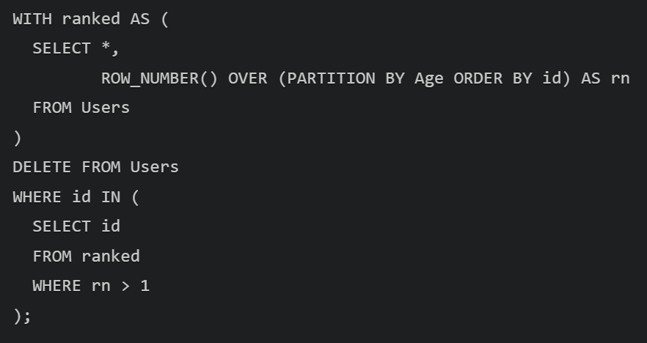
32. What is the difference between UNION and UNION ALL?
UNION is used for removing duplicates while UNION ALL keeps all duplicates. UNION is slower compared to UNION ALL because of de-duplication. You use UNION when you want to obtain unique records and UNION ALL when you want every row even if they are repeated.
33. Employee salary more than avg salary
Select * from employee
Where salary >( select avg(salary) from employee )
34. RANK, DENSE RANK, ROW_NUMBER
RANK:
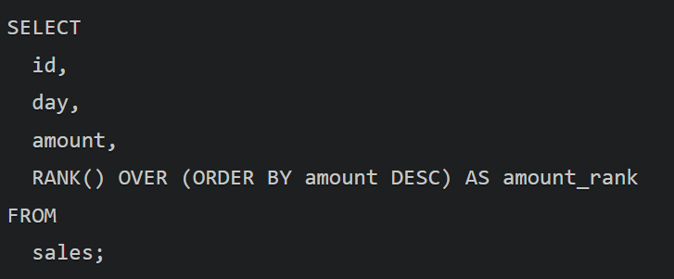
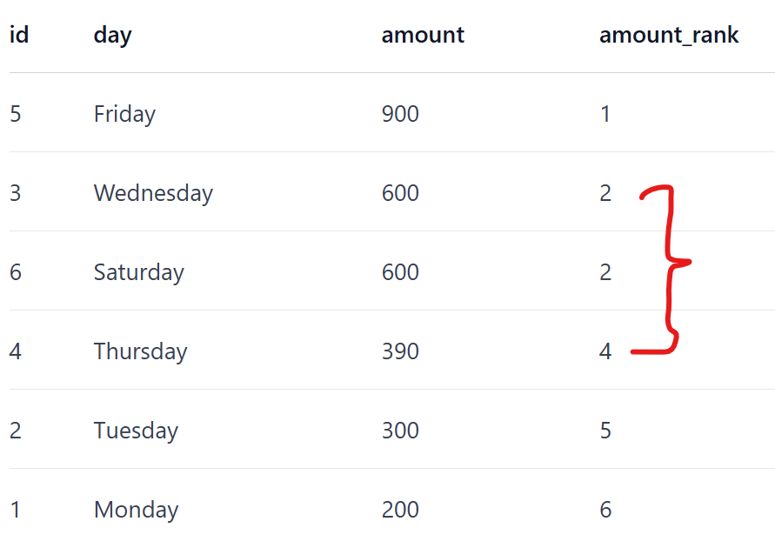

DENSE_RANK:
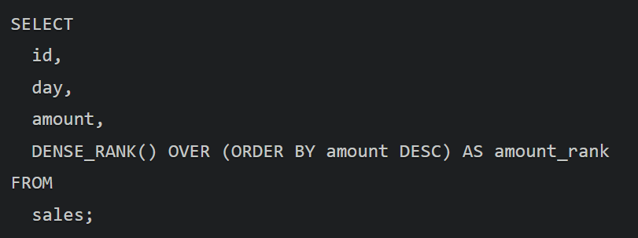
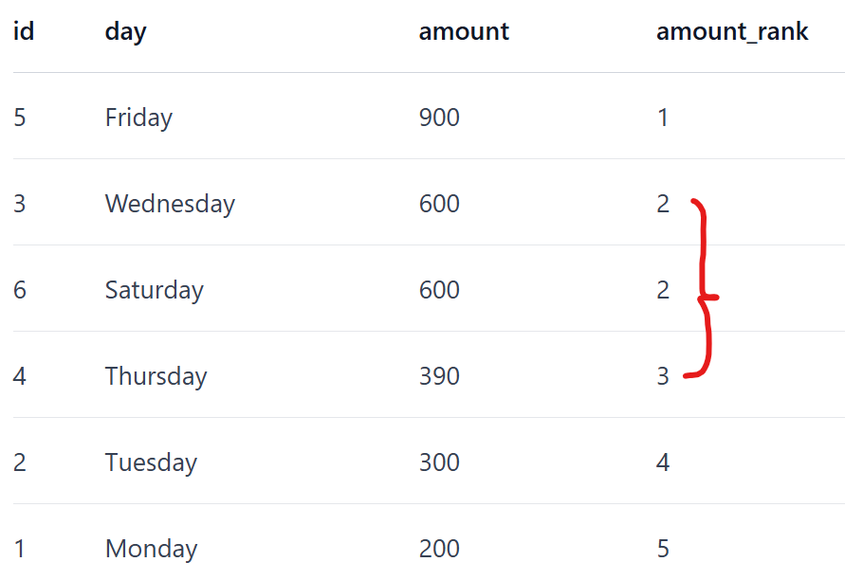

ROW_NUMBER:
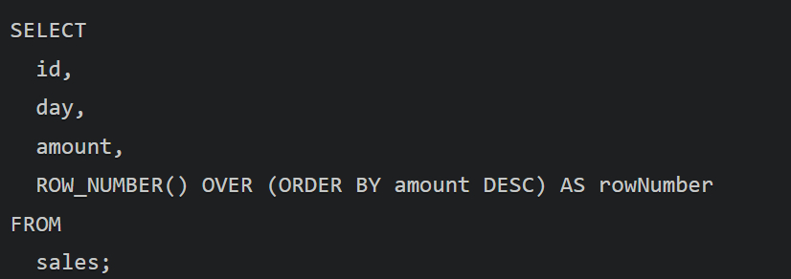
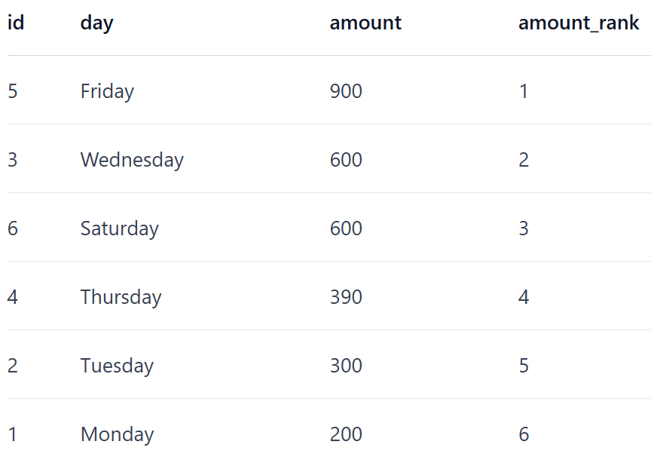
35. LAG vs LEAD
LAG(column_name, offset, default_value)
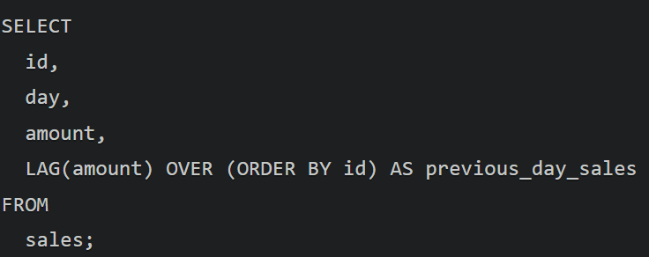
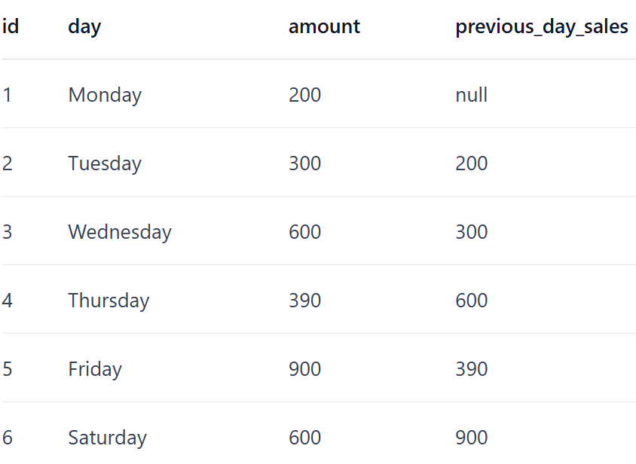

LEAD
